[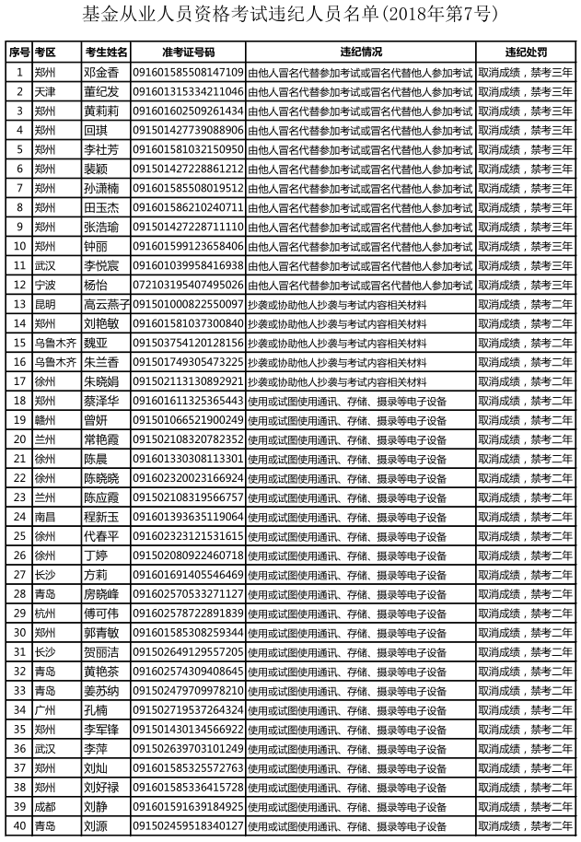](http://www.amac.org.cn/upload/xhdt/zxdt/1542857392840.png)

[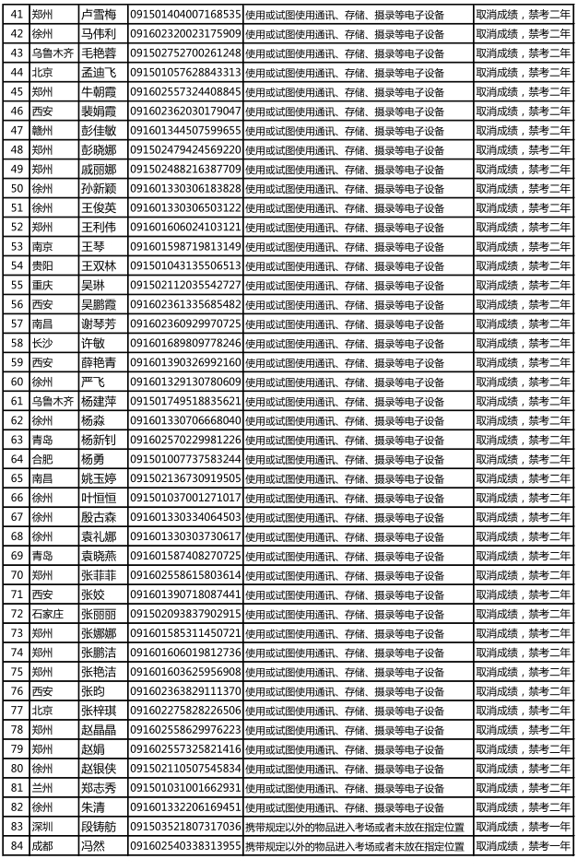](http://www.amac.org.cn/upload/xhdt/zxdt/1542857428302.png)

[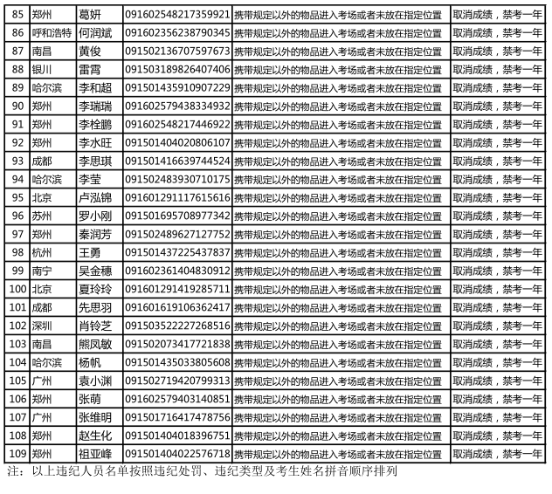](http://www.amac.org.cn/upload/xhdt/zxdt/1542857443481.png)